F-53 : Vendor Outgoing Payment

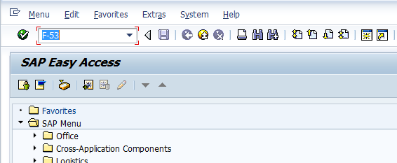
- Input F-53 in Transaction box and press Enter key

Vendor Outgoing Payment
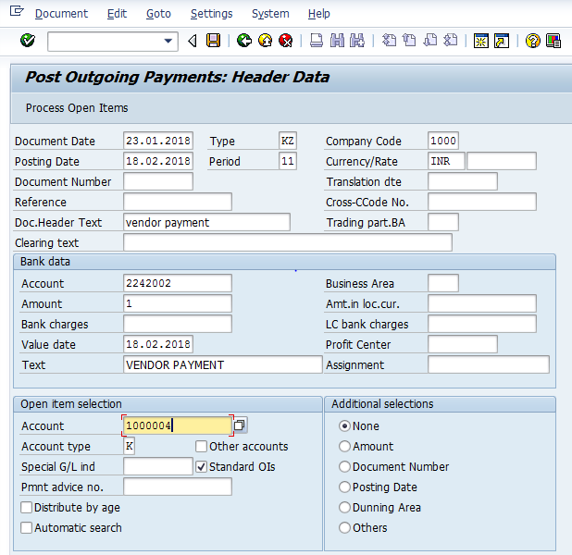
The following are the Input fields under the Document Header data of Vendor Outgoing Payment
- Document Date: Input the Invoice date in the field
- Posting Date: Input the transaction date in the Posting date field
- Document Type: Input the Document type KZ for Vendor payment
- Company Code: Input the Company code 1000 in this field
- Currency: Input the Currency INR in the Currency field
- Reference: Input the Reference field with Reference (invoice) number
- Clearing Text: Input the text information in this field
Bank Data: Under this Section
- Account: Place the cursor on the field and press F4. List of GL Accounts will appear, select respective Bank outgoing GL Account and press Enter key
- Amount: Input the amount
- Profit Center: Input the respective Profit center by selecting from the drop down list
- Text: Input the text information in this field
Open Item Selection: Under the section
- Account: Input the Vendor Number in this field
- Account Type: Input the Account type “K” (Vendors) from drop down list

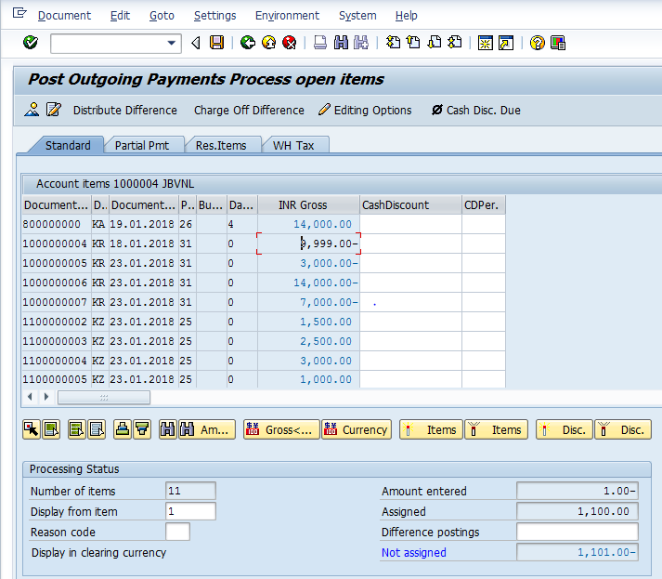
- Select All items Icon and select Deactivate items tab
- Double Click on the line items(Debit and Credit) which will get activated(turns in to Blue colour)
- Select Document option in Menu, choose Simulate option.

Simulation of Transaction before posting:
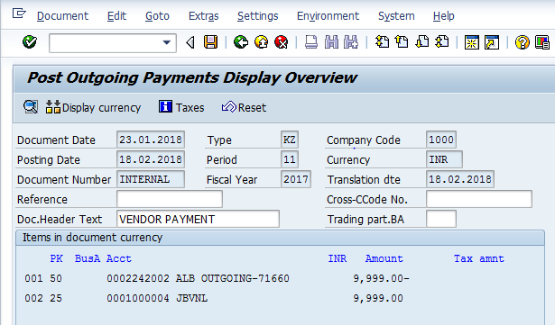
Simulate: Click on Simulate option. System will display the line items (Debit and Credit entry).
- Check the entries, if the entries are correct, click to Post Button
- If the entries are not okay, then go to Main screen and take required action to correct it.

Document Posting
- Document is posted, An information will be populated at the bottom of the screen

Document Display View
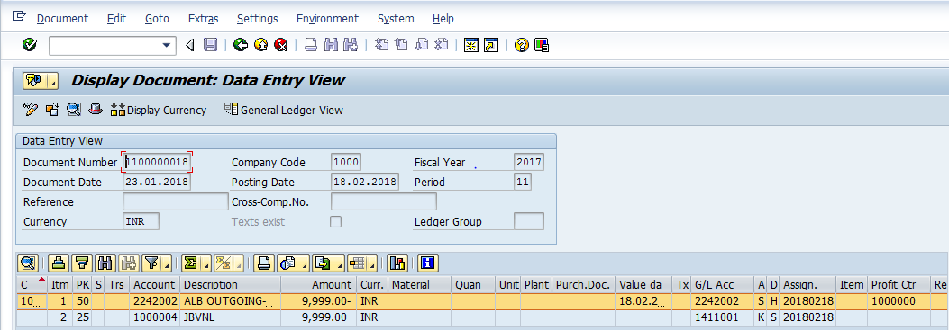
We can view the transaction in two ways:
- Display Document: From Menu bar select Document option it will display the options Change, Display, Post and Save as completed. Choose Display option. Document successfully got posted will get displayed
- Input FB03 in Transaction box and system will take us to Document Display screen. Input the Document number and Press Enter key. Document posted will get displayed.

Manual End

